# [**‘Law & Order: SVU’ Promotes Demore Barnes To Series Regular For Season 22 Of NBC Drama**](https://deadline.com/2020/10/law-order-svu-demore-barnes-promoted-series-regular-season-22-nbc-drama-deputy-chief-christian-garland-1234592466/)



By [Nellie Andreeva](https://deadline.com/author/nellie/)

## [**Nellie Andreeva**](https://deadline.com/author/nellie/)

*Co-Editor-in-Chief, TV*

[@DeadlineNellie](https://twitter.com/DeadlineNellie)

#### **More Stories By Nellie**

* [TNets Strategy Comes Into Focus With Lower-Cost, Mass-Appeal Shows As New Chief Kathleen Finch Meets With Creative Community](https://deadline.com/2022/09/tnt-tbs-programming-strategy-plans-warner-bros-discovery-merger-shows-tnets-1235117997/)
* [‘Reacher’: Shaun Sipos To Star In Season 2 Of Prime Video Series](https://deadline.com/2022/09/reacher-shaun-sipos-season-2-prime-video-series-1235118731/)
* [Timothy Olyphant To Star In Steven Soderbergh’s ‘Full Circle’ HBO Max Limited Series](https://deadline.com/2022/09/timothy-olyphant-cast-steven-soderbergh-ed-solomons-hbo-max-limited-series-full-circle-1235117627/)

[**VIEW ALL**](https://deadline.com/author/nellie/)

October 6, 2020 3:00pm

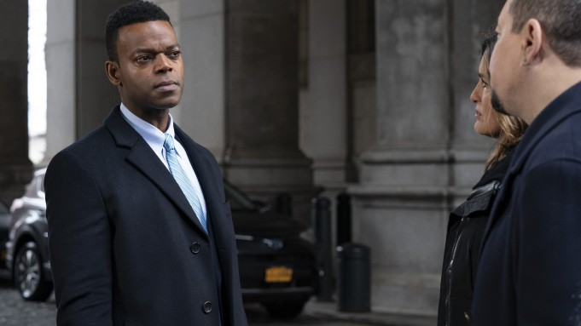

Photo: Virginia Sherwood/NBC

[Demore Barnes](https://deadline.com/tag/demore-barnes/) has been promoted to series regular for the upcoming 22nd season of [NBC](https://deadline.com/tag/nbc/)’s[*Law & Order: SVU*](https://deadline.com/tag/law-order-svu/)*.*

Barnes will continue in the role of Deputy Chief Christian Garland, a forthright, analytical and charismatic leader, eager to apply more contemporary principles to the NYPD while navigating its political minefields along with Capt. Benson (Mariska Hargitay). He was introduced early last season and recurred on the Wolf Entertainment/Universal TV show, appearing in more than a third of the episodes.

*Law & Order: SVU* [started production](https://deadline.com/2020/09/law-order-start-production-new-york-dick-wolf-chicago-fire-chicago-pd-chicago-med-fbi-fbi-most-wanted-1234576263/) on Season 22 Sept. 14 in New York.

Canadian Barnes is currently wrapping up his last year as series narrator Mr. Ibis in Starz’s *American Gods*. He starred as Wayne Taylor in Paramount Network’s limited series *Waco* and recurred on DC’s *Titans* for DC Universe as well as *The Flash* and *Supernatural* for the CW, *Hemlock Grove* for Netflix, SyFy’s *12 Monkeys,* USA’s *Covert Affairs* and NBC’s *Hannibal.* He also guest starred as Attorney Marshall Mathews on NBC’s One Chicago, from Wolf Entertainment and Uni TV. Barnes, probably best known for playing Hector Williams on CBS drama series *The Unit*, is repped by Buchwald and The Characters Agency.